**Karachi:**

Hawk's Bay

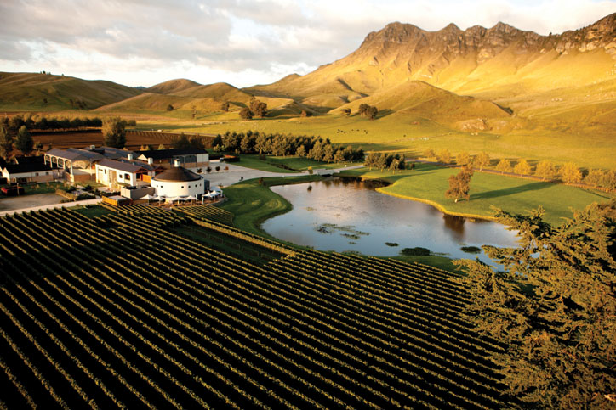

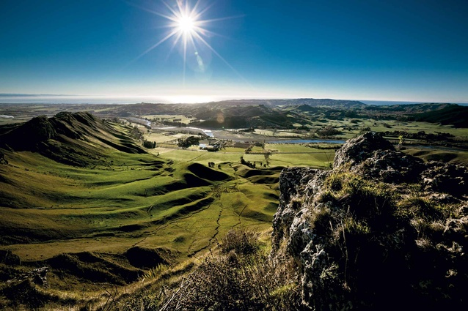

**Hawke's Bay** Or **Hawkesbay** is a beach in Karachi, Sindh, Pakistan located 20km at south-west of Karachi. This beach is named after Bladen Wilmer Hawke, who owned a beach house here in 1930s. Hundreds of people visit here daily for swimming, camel and horse riding and for vacations.